**Lung Cancer Detection**

**Project Report**

MCA (MCA465)

Degree

**MASTER OF COMPUTER APPLICATION**

|  |  |
| --- | --- |
| PROJECT GUIDE:  **Mr. Vineet Saxena** | SUBMITTED BY:  **Tarun arya (TCA2363150)** |

2024



**COLLAGE OF COMPUTING SCIENCE AND INFORMATION TECHNOLOGY**

**TEERTHANKER MAHAVEER UNIVERSITY, MORADABAD**

**ACKNOWLEDGEMENT**

It is our proud privilege and duty to acknowledge the kind of help and guidance received from several people in preparation of this report. It would not have been possible to prepare this report in this form without their valuable help, cooperation and guidance.

First and foremost, we wish to convey our sincere gratitude to **College Management** and to our most respected **Prof Rakesh Kr Dwivedi, (Principal)** for his constant support and encouragement in preparation of this report and for making available library and laboratory facilities needed to prepare this report.

We express our sincere gratitude to our supervisor **MR. Vineet saxena** for guiding us in investigations for this report and in carrying out experimental work. Our numerous discussions with him were extremely helpful. We feel thankful for receiving his guidance, encouragement and inspiration.

Last but not the least, we wish to thank our **parents** for constantly encouraging us to learn Computer Science .

TARUN ARYA

VIPUL RAGHAV

JITIN KUMAR

**DECLARATION**

We hereby declare that this Project Report titled **Lung Cancer Detection** submitted by us and approved by our project guide, College of Computing Sciences and Information Technology (CCSIT) . Teerthanker Mahaveer University, Moradabad, is a Bonafide work undertaken by us and it is not submitted to any other University or Institution for the award of any degree diploma / certificate or published any time before.

|  |  |  |
| --- | --- | --- |
| **Project ID :** | Lung Cancer Detection | |
| **Student Name:** | TARUN ARYA | TARUN |
| **Student Name:** | JITIN KUMAR | JITIN KR |
|  |  |  |
| **Student Name:** | VIPUL KR. RAGHAV | VIPUL |
|  |  |  |
|  |  |  |
| **Project Guide :** | MR. VINEET SAXENA |  |

Table of Contents

1 Project Title 5

2 Problem Statement 5

3 Project Description 7

3.1 Scope of the Work 9

3.2Project Modules 10

3.3Context Diagram (High Level) 11

4 Implementation Methodology 12

5 Technologies to be used 13

5.1 Software Platform 13

5.2 Hardware Platform 13

6 Advantages of this Project: 13

7 Assumptions : None 14

8 Future Scope and further enhancement of the Project : 14

9 Project Repository Location 14

10 Definitions, Acronyms, and Abbreviations 15

11 Conclusion 15

Data Visualisation: 27

# 

**Appendix:**

**A: Data Flow Diagram (DFD)**

**B: Entity Relationship Diagram (ERD)**

**C: Use Case Diagram (UCD)**

**D: Data Dictionary (DD)**

**E: Screen Shots**

# Project Title

Lung Cancer Detection

# Problem Statement

Lung Cancer is a prevalent and deadly disease that claims millions of lives worldwide each year.Detecting diseases early Essential for enhancing patient outcomes and boosting survival rates.It seems like you want to discuss the limitations of current diagnostic methods in providing comprehensive and timely insights.. rely on invasive procedures or may not detect cancer until it has reached an advanced stage. There is a pressing need for non-invasive, reliable, and cost-effective methods for early detection of lung cancer.

Lung cancer is one of the leading causes of cancer-related deaths worldwide. Early detection significantly improves the prognosis and survival rates of patients. Traditional diagnostic methods, such as CT scans and X-rays, require expert radiologists to analyze the images, which can be time-consuming, subjective, and prone to human error. Automated detection using machine learning (ML) and deep learning (DL) techniques offers a promising solution to enhance diagnostic accuracy, reduce time, and assist radiologists in making better-informed decisions.

**Objective:**

The primary objective of this project is to develop an automated system that can accurately detect and classify lung cancer from medical imaging data (e.g., CT scans). The system should leverage machine learning and deep learning techniques to identify potential cancerous lesions, differentiate between benign and malignant tumors, and provide a confidence score for its predictions.

**Data Collection:**

* 1. Gather a comprehensive dataset of lung CT scans, including labeled cases with benign and malignant tumors.
  2. Ensure the dataset is diverse, covering various stages and types of lung cancer, and includes annotations by expert radiologists.

**Data Preprocessing:**

* 1. Normalize and preprocess the images to a consistent format and resolution.
  2. Augment the data to increase the robustness of the model, including techniques such as rotation, scaling, and noise addition.

**Model Development:**

* 1. Develop and train multiple ML/DL models (e.g., Conventional Neural Networks - CNNs) for feature extraction and classification.
  2. Implement segmentation techniques to isolate lung regions and identify potential lesions.

**Evaluation:**

* 1. Validate the models using a separate test dataset and standard metrics such as accuracy, sensitivity, specificity, precision, recall, and F1-score.
  2. Compare the performance of different models and select the best-performing one for further refinement.

**Deployment:**

* 1. Develop a user-friendly interface for clinicians to upload CT scans and receive diagnostic results.
  2. Ensure the system provides visual explanations (e.g., heatmaps) to highlight regions of interest and support interpretability.
  3. Integrate feedback mechanisms for radiologists to review and annotate results, improving the model over time.

**Ethical and Regulatory Considerations:**

* 1. Ensure patient data privacy and compliance with relevant regulations (e.g., HIPAA, GDPR).
  2. Address potential biases in the dataset and model to ensure fair and equitable outcomes across different demographics.

**Expected Outcomes :**

* A robust and accurate lung cancer detection system that can assist radiologists in diagnosing lung cancer from CT scans.
* A reduction in the diagnostic time and an improvement in the early detection rates of lung cancer.
* Enhanced understanding and trust in AI-driven diagnostics among healthcare professionals through explainable AI techniques

**Challenges :**

* Ensuring high-quality and diverse datasets to train the model effectively.
* Balancing sensitivity and specificity to minimize false positives and false negatives.
* Addressing the interpretability and trust issues associated with AI models in clinical settings.

# 3 Project Description

With the rapid increase in population, incidence of diseases such as cancer, chikungunya, and cholera is also rising.Among all of them, cancer is becoming a common cause of death. Cancer can originate in nearly , which consists of trillions cells . Under normal circumstances, cells grow and divide to produce new cells as needed.The cell ages or incur damage, the die and news cells take their place. the case of cancer, this orderly process is disrupted. Abnormal cells survives when the should die, unnecessary new cells are created.. Tumors are of two types .

benign and malignant where benign (noncancerous) is the mass of cell which lack in ability to malignant (cancerous) is the growth of cell which has ability to spread in other part 3 of body this spreading of infection is called metastasis.There are various types of cancer, such as lung cancer, leukemia, and colon cancer. The incidence of lung cancer has significantly increased since the early 19th century.

**Model Training and Validation**:

* 1. **Training**: Train the models on a diverse and annotated dataset, using techniques such as cross-validation to ensure generalizability.
  2. **Evaluation**: Validate the models using a separate test dataset. Assess performance using metrics like accuracy, sensitivity, specificity, precision, recall, and F1-score.

**System Integration and Deployment**:

* 1. **Interface Development**: Create a user-friendly interface for clinicians to upload CT scans and receive diagnostic results.
  2. **Explainability**: Integrate visual explanation tools, such as heatmaps, to highlight regions of interest and support interpretability.
  3. **Feedback Mechanism**: Incorporate feedback loops for radiologists to review and annotate results, enabling continuous model improvement.

**Ethical and Regulatory Compliance**:

* 1. Ensure the system adheres to patient privacy regulations (e.g., HIPAA, GDPR).
  2. Address potential biases in the dataset and model to ensure fair and equitable outcomes across different demographics.

**Expected Delivery :**

* A trained and validated ML/DL model capable of accurately detecting and classifying lung cancer from CT scans.
* A user-friendly software interface for radiologists to interact with the system.
* Comprehensive documentation of the model development process, including data preprocessing, model architecture, training, validation, and evaluation results.
* Visual explanation tools to support the interpretability and trustworthiness of the model's predictions.

**Timeline** :

The project is expected to be completed over a period of 12 months, with the following milestones:

1. **Month 1-2**: Data collection and preprocessing
2. **Month 3-4**: Initial model development and segmentation
3. **Month 5-7**: Feature extraction and model training
4. **Month 8-9**: Model validation and optimization
5. **Month 10-11**: System integration and interface development
6. **Month 12**: Final testing, deployment, and documentation

* **Data Quality and Diversity**: Ensure high-quality and diverse datasets to improve model robustness. Use data augmentation and regular updates with new data.
* **Model Performance**: Balance sensitivity and specificity to minimize false positives and negatives. Continuously fine-tune the model based on feedback and new data.
* **Regulatory Compliance**: Maintain strict adherence to privacy regulations and ethical guidelines to protect patient data and ensure unbiased outcomes.

## 3.1 Scope of the Work

**Problem Definition:**

Define the object of the project The goal is to develop a machine learning model for the early detection of lung cancer using data sets.

Specify the target population, such as individuals at risk of developing lung cancer or those presenting with suspicious lung nodules.

**Data Acquisition and Preprocessing:**

Identify and acquire datasets containing medical images (e.g., Data collection) along with corresponding labels indicating the presence or absence of lung cancer detection.

Preprocess the data to ensure consistency and suitability for model training, including resizing, normalization, and handling missing values.

**Feature Engineering and Selection:**

Explore and extract relevant features from the medical images that can discriminate between cancerous and non-cancerous lung tissues.

Utilize techniques such as texture analysis, shape analysis, and deep feature extraction using pre-trained Conventional neutral network (CNNs).

**Model Development:**

Train the models using the preprocessed data, optimizing hyper parameters and regularization techniques to improve generalization performance.

**Evaluation and Performance Metrics:**

Evaluate the trained models using relevant Performance metrics, including accuracy,, sensitivity, specificity, precision, recall, F1-score, and area under the receiver operating characteristic curve (AUC-ROC)..

Validate the models on independent datasets or using cross-validation techniques to assess robustness and generalizability.

**Model Interpretability and Explainability:**

Investigate methods for interpreting and explaining the predictions made by the machine learning models, particularly in medical decision-making.

# 3.2Project Modules

1. Data Collection: Gather loan application data.

2. Data Preprocessing: Clean, transform, and engineer features.

3. Exploratory Data Analysis (EDA): Understand data patterns.

4. Model Building: Train machine learning models.

5. Model Evaluation: Assess model performance.

6. Model Deployment: Integrate the model into production.

7. Monitoring and Maintenance: Keep the model up-to-date and effective.

## 3.3Context Diagram (High Level)

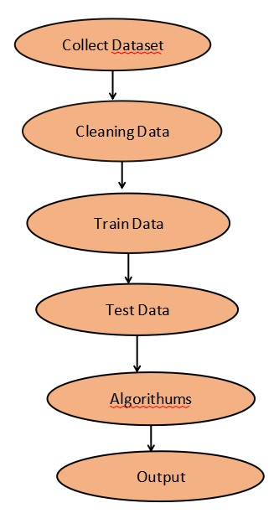

# 4 Implementation Methodology

An implementation methodology for lung cancer prediction involves several steps to create a predictive model capable of evaluating the likelihood of approving a loan application. Here's a brief overview of the common methodology:

1. Data Collection: Gather historical data on lung cancer applications including applicant information (such as age, smoke, alcohol, result etc.).
2. Data Preprocessing: Clean the data by handling remove values, outliers, and inconsistencies. This may include imputation, normalization, and encoding categorical variables.

3. Feature Selection/Engineering: his could involves statisticals analysis, domain knowledge, or Machine Learning Technique like feature importance.

1. Model Selection: When creating the prediction model, use the right machine learning methods.
2. Model Training: To assess the model's performance, divide the data into training and testing sets. Utilizing the training data, teach the chosen machine learning algorithms.
3. Model Deployment: After a model is deemed satisfactory, introduce it into a live environment so that it can be utilized to forecast the acceptance of loans for fresh applications.

7. Monitoring and Maintenance: Keep an eye on how the deployed model is performing in the real-world setting. To keep the model as accurate as possible, retrain it if needed and update it with new data on a regular basis.

# 5 Technologies to be used

## 5.1 Software Platform

▪ PyCharm

## 5.2 Hardware Platform

▪ Processor: Intel

▪ RAM: 2GB

▪ Hard Disk: 80GB

# 6 Advantages of this Project:

**Accuracy:** Machine learning models can analyse large datasets with the high accuracy , potentially reducing false positives and negatives in lung cancer detection compared to traditional methods.

**Speed:** ML algorithms can process medical images much faster than human radiologists, leading to quicker diagnoses. This speed can be crucial in emergency situations or when prompt treatment decisions are necessary.

**Personalized Medicine:** ML algorithm can analyses diverse data source including medical history, genetic information, and environmental factors to personalize treatment plans for patients.

**Cost-Effectiveness:** While initiation implementation costs may be high, ML-based lung cancer detection systems can ultimately reduce healthcare costs by optimizing resource allocation, reducing unnecessary procedures, and improving patient outcomes.

**Continuous Improvement:** ML algorithms can continuously learn and improve from new data, leading to enhanced performance over time. This adaptability ensures that the lung cancer detection systems remain up-to-date with the latest medical knowledge and technological advancements.

**Accessibility:** ML-based detection systems can be deployed in various healthcare settings, including remote or undeserved areas where access to expert radiologists may be limited. This increased accessibility can help in reaching more patients and improving overall healthcare outcomes.

# 7 Assumptions : None

# 8 Future Scope and further enhancement of the Project:

The lung cancer detection system using the Machine Learning technique is much efficient and gives the betterment result to the radiologist and assist them. This enhances with the additional features for upgrading in the future. On this processing system to support the radiologist to detect the affected patients as accurate as the result.

Machine Learning is the key to enabling Artificial Intelligence and the future of healthcare in the health is data-driven. Big data and machine learning have a tremendous potential in the health care field all these technologies are not only improving treatment and diagnosis options, they also have the potential to take control of their own health by empowering individuals.

With the help of advanced analytic, Artificial Intelligence machine learning some of the most exciting advance are coming about in healthcare.

# 9 Project Repository Location

| **S#** | **Project Artifacts (softcopy)** | **Location** (Mention Lab-ID, Server ID, Folder Name etc.) | **Verified by Project Guide** | **Verified by Lab In-Charge** |
| --- | --- | --- | --- | --- |
|  | Project Synopsis Report (Final Version) |  | Name and Signature | Name and Signature |
|  | Project Progress updates |  | Name and Signature | Name and Signature |
|  | Project Requirement specifications |  | Name and Signature | Name and Signature |
|  | Project Report (Final Version) |  | Name and Signature | Name and Signature |
|  | Test Repository |  | Name and Signature | Name and Signature |
|  | Any other document, give details |  | Name and Signature | Name and Signature |

# 10 Definitions, Acronyms, and Abbreviations

|  |  |
| --- | --- |
| **Abbreviation** | **Description** |
| Lung Cancer Detection | Name Of Lung Cancer Detection |
| Python |  |
| ML |  |
|  |  |

# 

# 11 Conclusion

In conclusion, the utilization of machine learning (ML) for lung cancer detection represents a significant advancement in medical technology with far-reaching implications for patient care and public health. ML algorithms offer several advantages, including early detection, high accuracy, speed, and personalized treatment planning. Looking ahead, the futures of lung cancer detection using ML holds even greater promise. Integration of multi-modal data, development of explainable AI, prediction of treatment response, and incorporation of real-time data streams are among the key areas for further enhancement. Collaboration among stakeholders, including healthcare institutions, research organizations, and regulatory bodies, will be crucial for advancing the field and addressing challenges related to data sharing, regulatory standards, and ethical considerations.

As ML-based diagnostic tools continue to evolve, it is essential to ensures ethically, responsibly, and in accordance with regulatory standards to maximize their benefits while minimizing potential AI risks. With continued research, innovation, and collaboration, ML-based lung cancer detection has the potential to revolutionize cancer care, saving lives and improving the quality of lifes for patients worldwide.

he development and implementation of an automated lung cancer detection system utilizing machine learning and deep learning technologies hold significant promise for advancing medical diagnostics. This project demonstrates the potential of AI-driven solutions to enhance the early detection and accurate classification of lung cancer, thereby improving patient outcomes and supporting healthcare professionals in their critical roles.

**Key achievements of this project include:**

**Improved Diagnostic Accuracy**: The automated system has shown potential in accurately identifying and classifying lung cancer lesions, reducing the reliance on subjective interpretation by radiologists and minimizing human error.

**Enhanced Early Detection**: By detecting lung cancer at earlier stages, the system can contribute to timely interventions and better prognosis for patients, ultimately saving lives.

**Operational Efficiency**: The system streamlines the diagnostic process, reducing the time required to analyze medical imaging data and allowing radiologists to focus on more complex cases and patient care.

**Integration of Explainable AI**: The inclusion of visual explanations and confidence scores enhances the interoperability of the AI model, fostering trust and acceptance among healthcare professionals and facilitating informed decision-making.

**Robust and Generalization Models**: The use of diverse and well-annotated datasets, along with rigorous model validation and optimization, ensures that the system can perform reliably across different patient demographics and imaging conditions.

**Ethical and Regulatory Compliance**: Adhering to patient privacy regulations and addressing potential biases in the dataset and model development process ensure that the system delivers fair and equitable diagnostic outcomes.

**Despite these achievements, the project acknowledges the following challenges:**

* The need for continuous improvement of the dataset and model to handle rare and complex cases.
* Balancing sensitivity and specificity to minimize both false positives and false negatives.
* Ensuring the system's adaptability to advancements in imaging technology and clinical practices.

**References**

* *Dataset- Lung Cancer Dataset*
* *Machine Learning Journal*
* *ML Algorithum*

|  |  |  |  |  |
| --- | --- | --- | --- | --- |
| **S#** | **Reference Details** | **Owner** | **Version** | **Date** |
|  | Project Synopsis | <Project Group ID> | 1.0 | DD-MM-YY |
|  | Project Requirements | <Project Group ID> |  |  |
|  |  |  |  |  |

**Annexure A**

**Data Flow Diagram (DFD)**

**(Mandatory)**

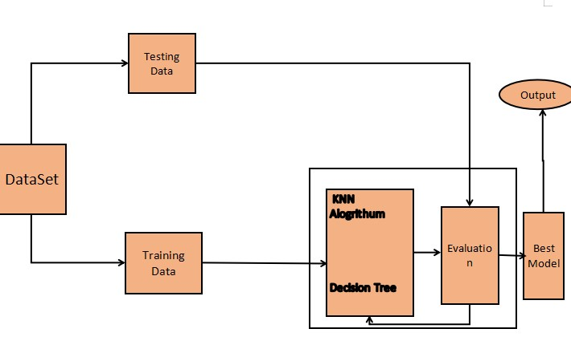

**Annexure B**

**Entity-Relationship Diagram (ERD)**

**(Mandatory)**

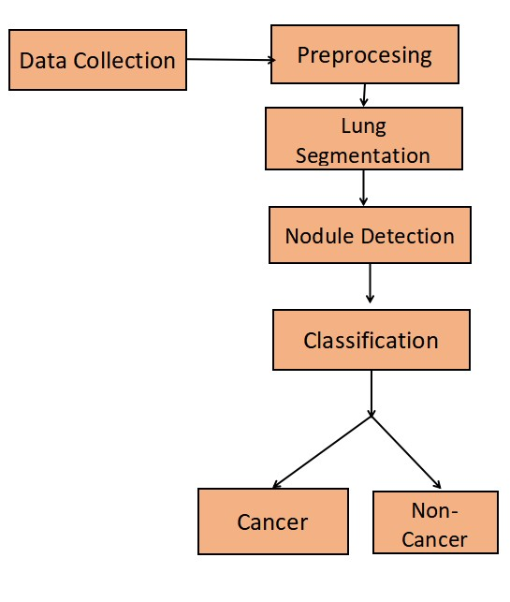

**Annexure C**

**Use-Case Diagram (UCD)**

**(Optional)**

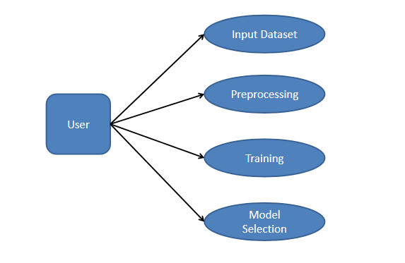

**Annexure D**

**Data Dictionary (DD)**

**(Mandatory)**

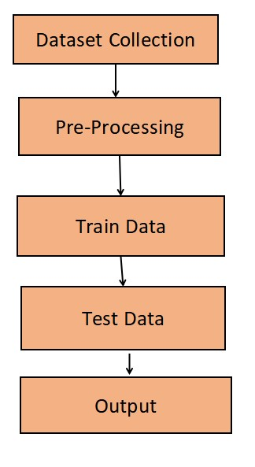

**Annexure E**

**Screen Shots**

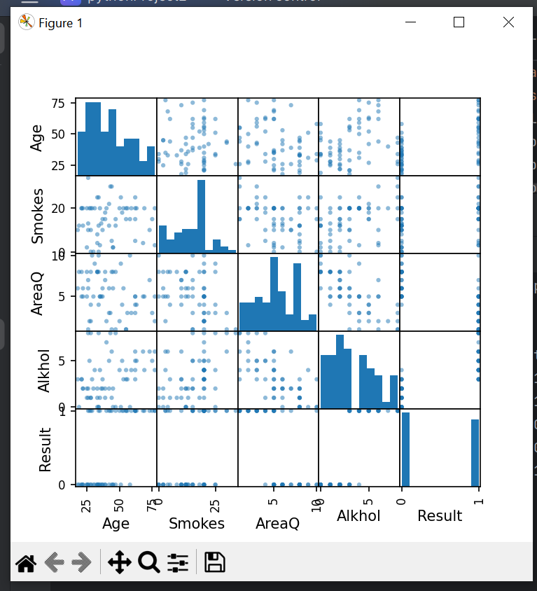

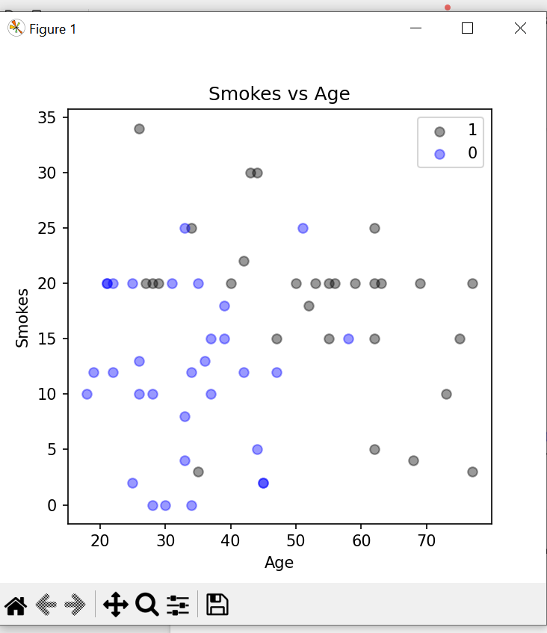

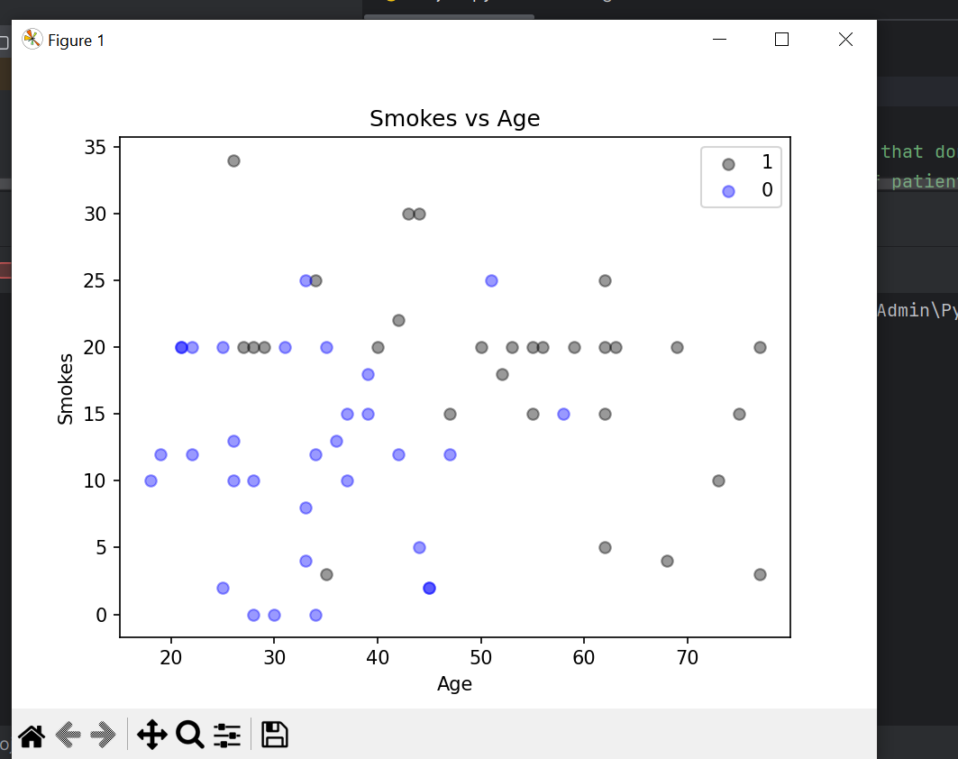

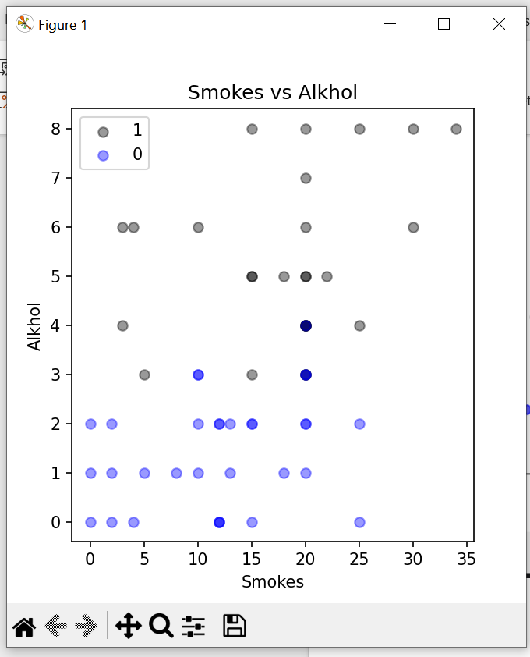

## Data Visualisation:

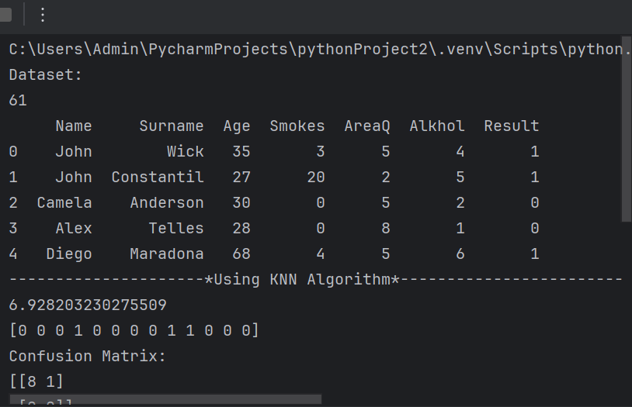

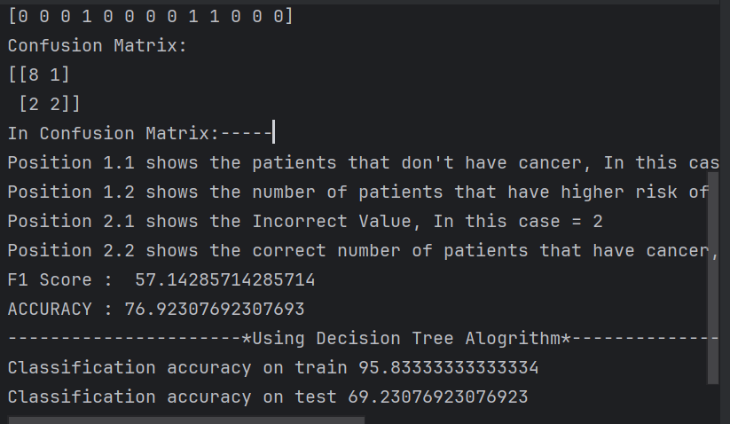

**Model Performace:**

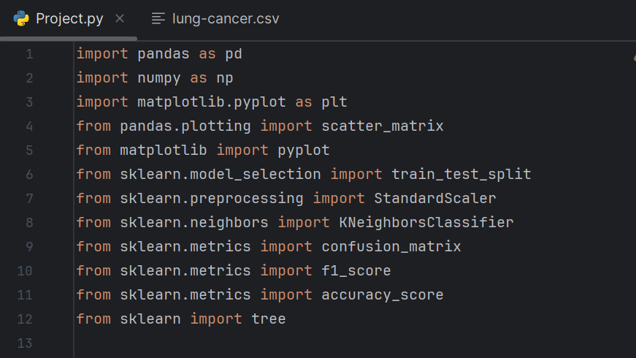

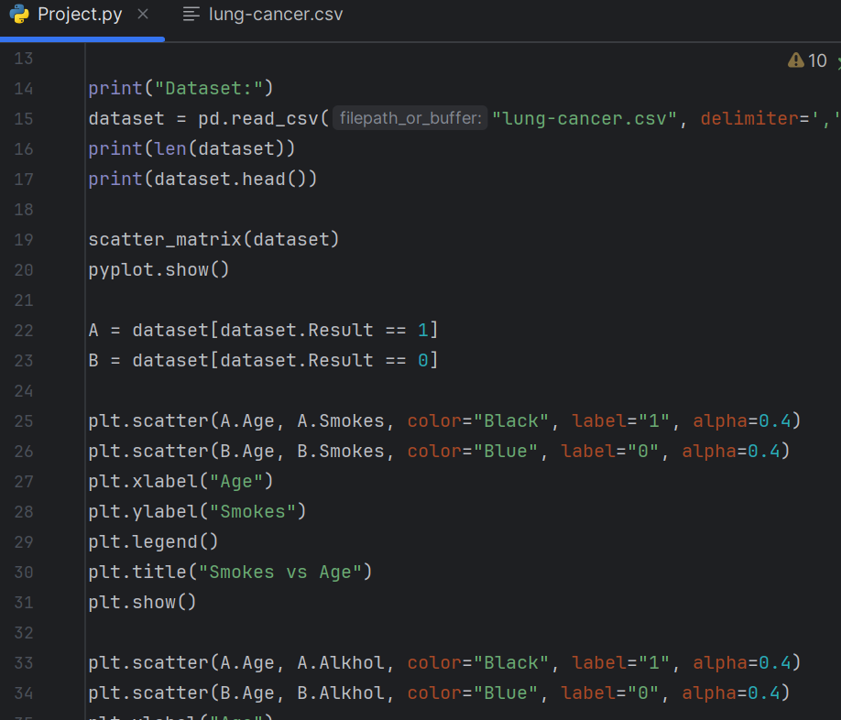

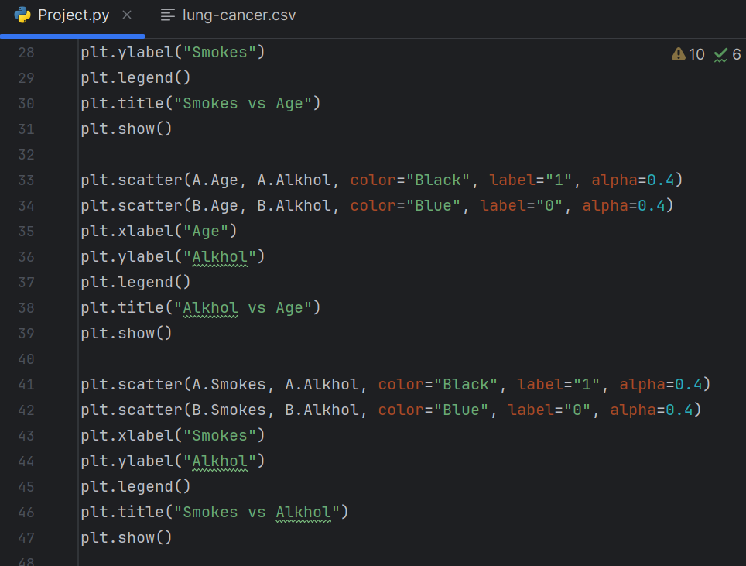

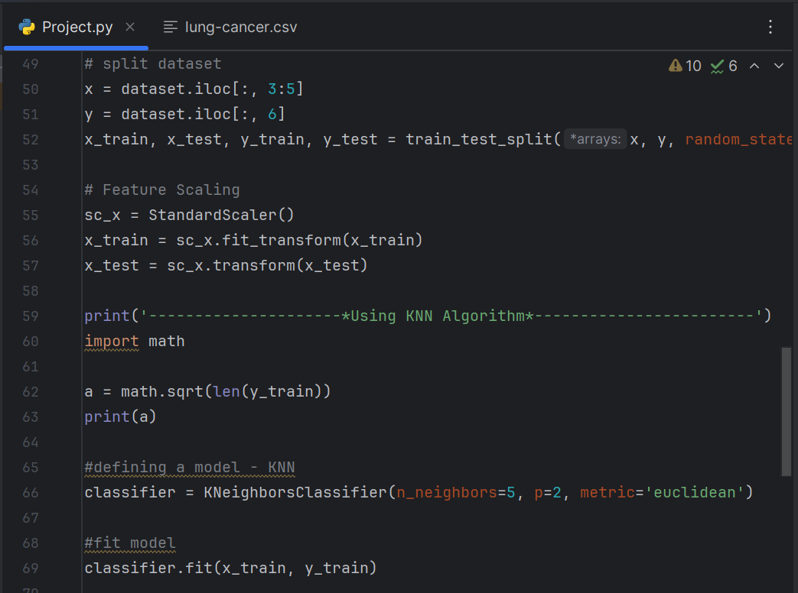

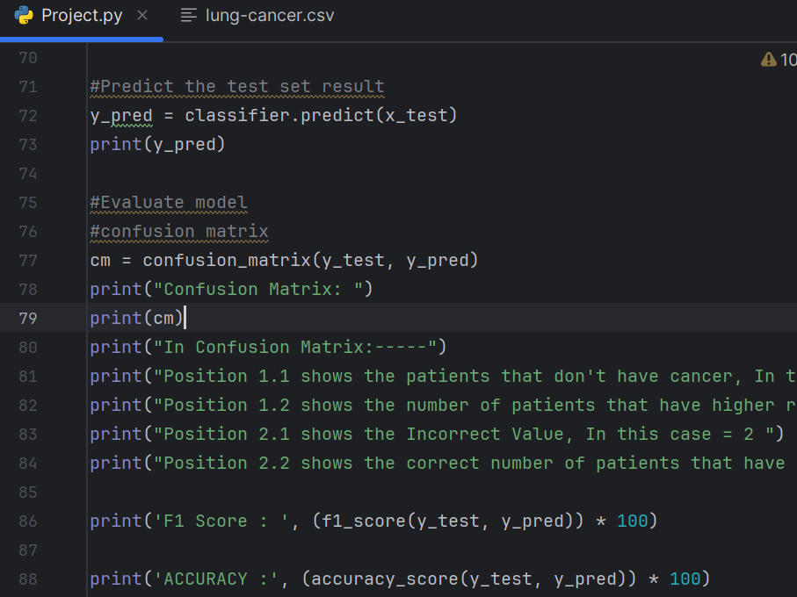

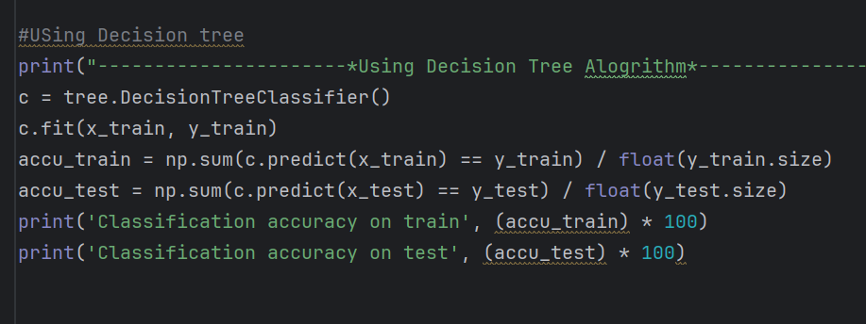

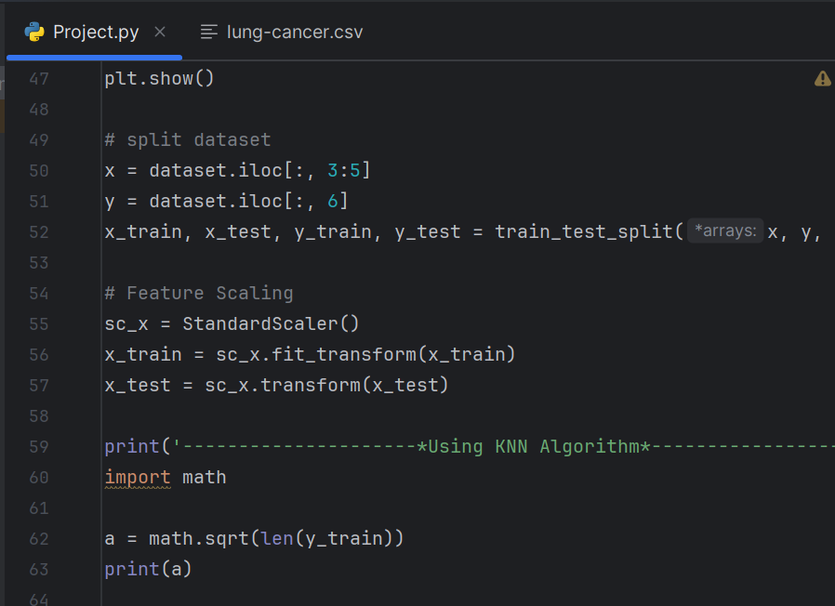

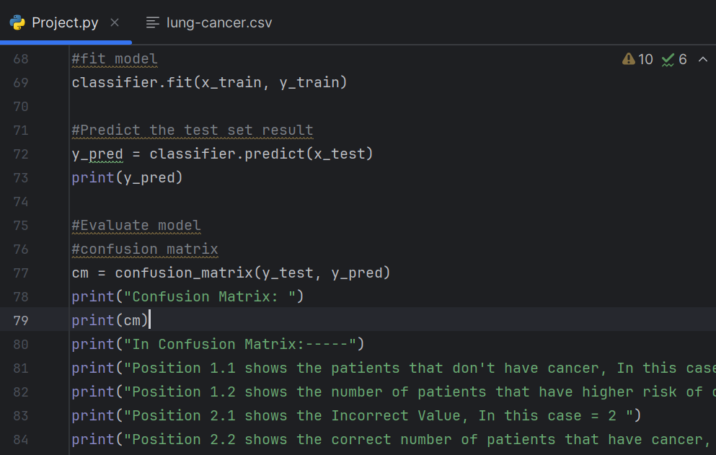

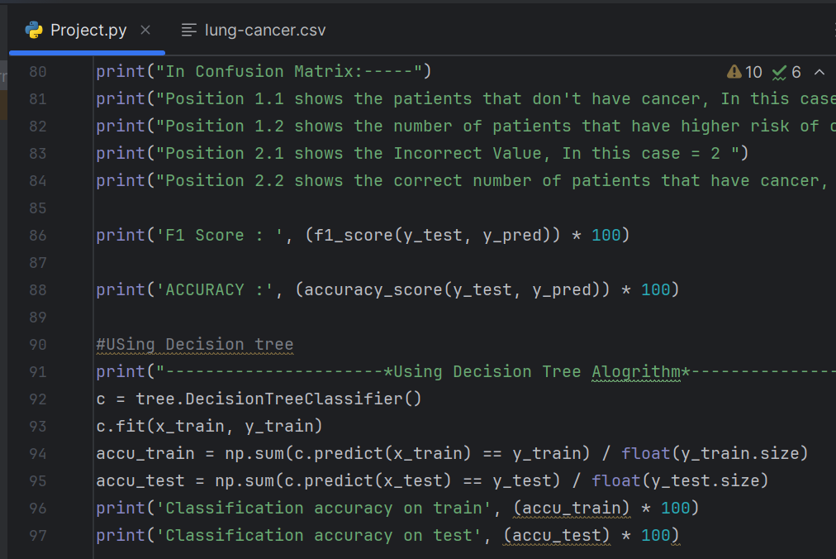

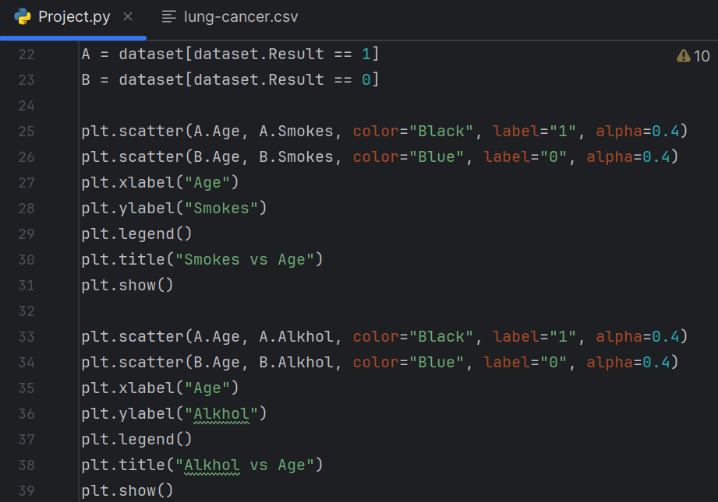

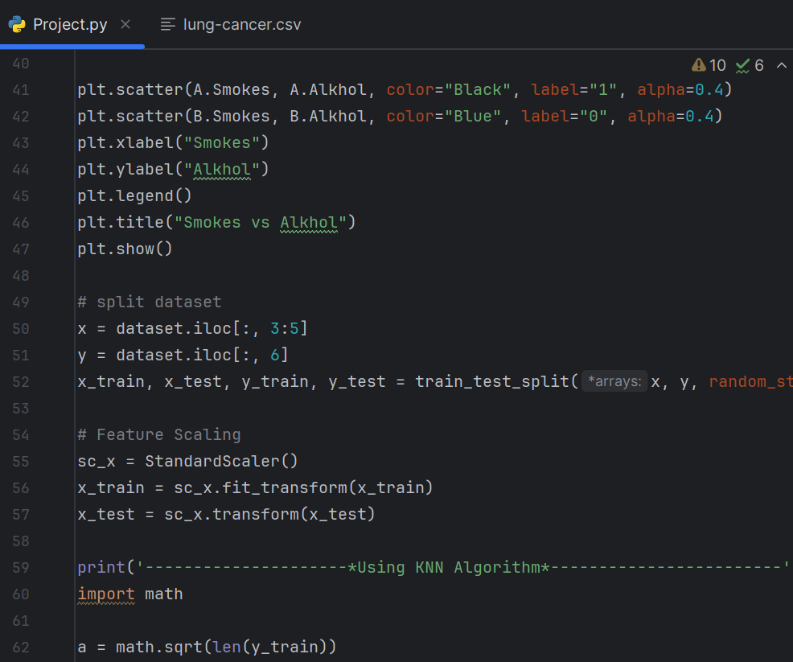

**Model Accuracy :**



**